**DEVELOP A MOBILE APPLICATION**

|  |  |
| --- | --- |
| **Team ID** | PNT2022TMID02439 |
| **Project Name** | Smart farmer-IOT enabled smart farming application |
| **Team Members** | Kamesh Kumar K , Kaviyaraj C , Javeed Akram Z , KavinSaran JK |

# **Step 1:** Login to MIT App Inventor

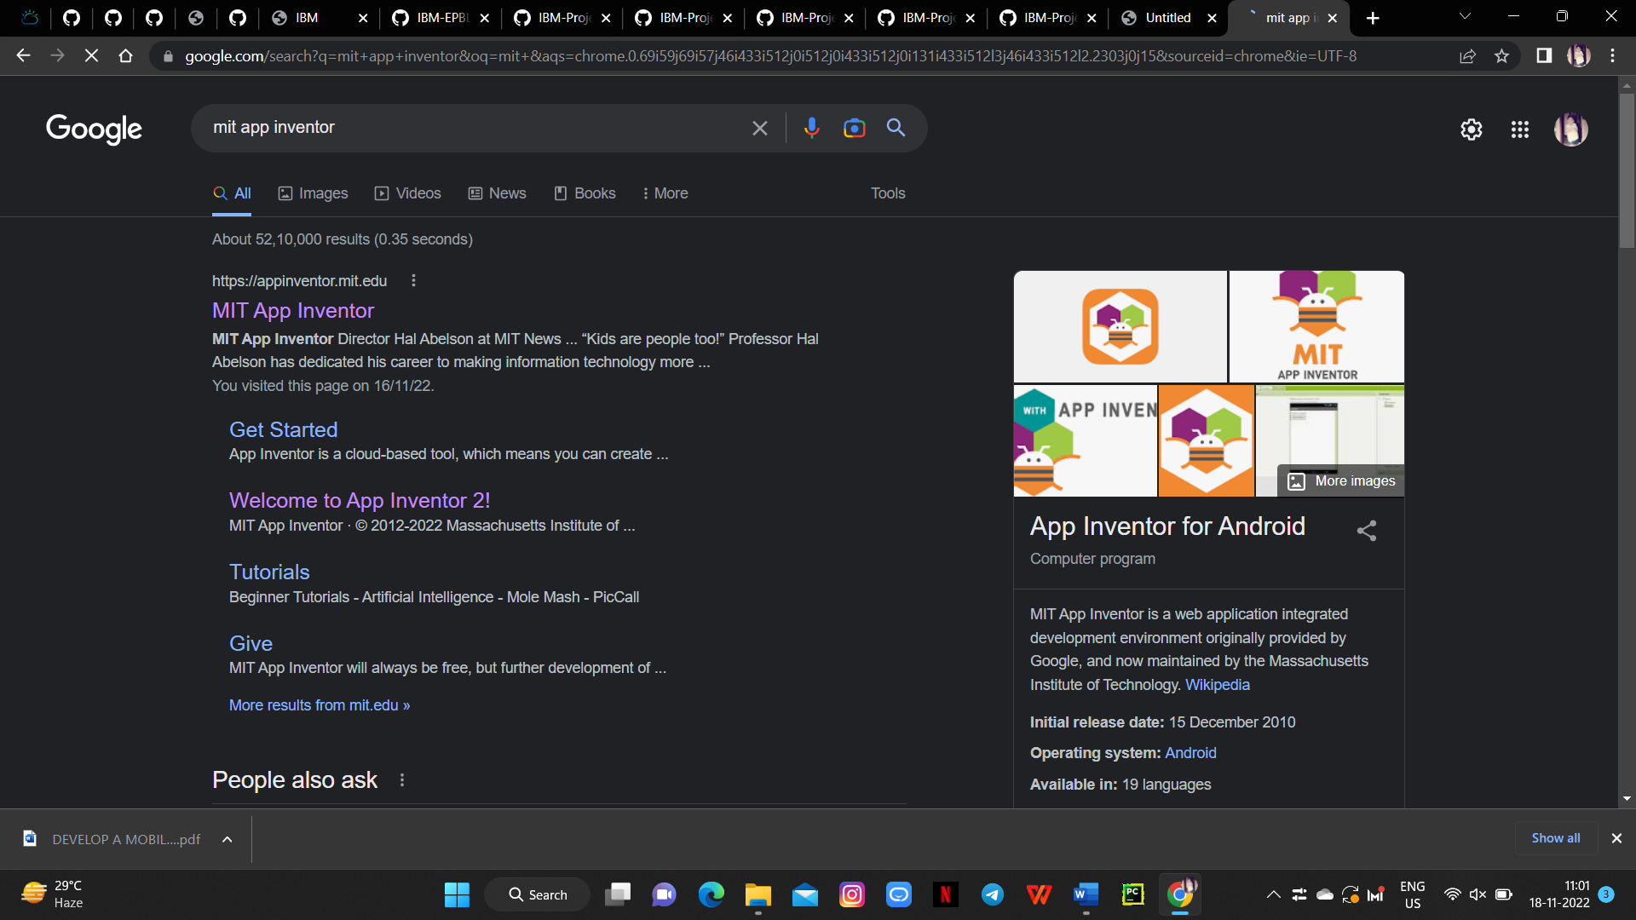

**Step 2:** Drop & place The Essential Features In The Front End Process

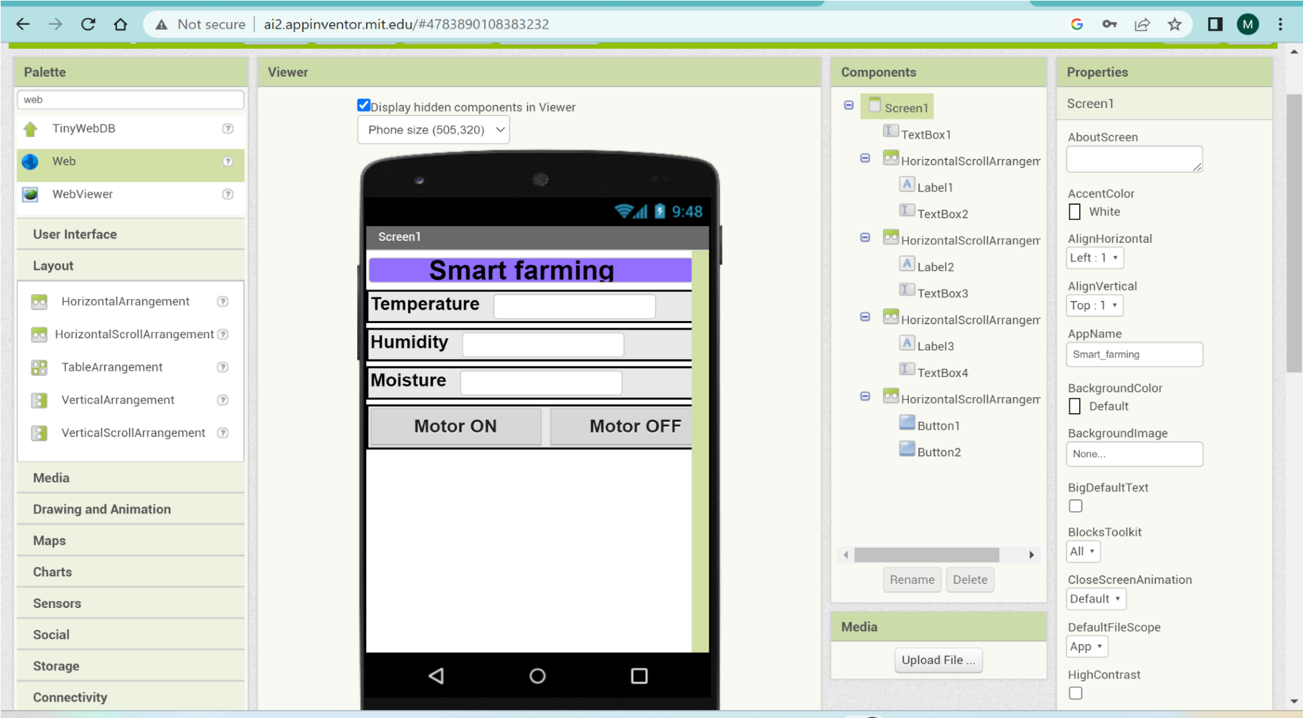

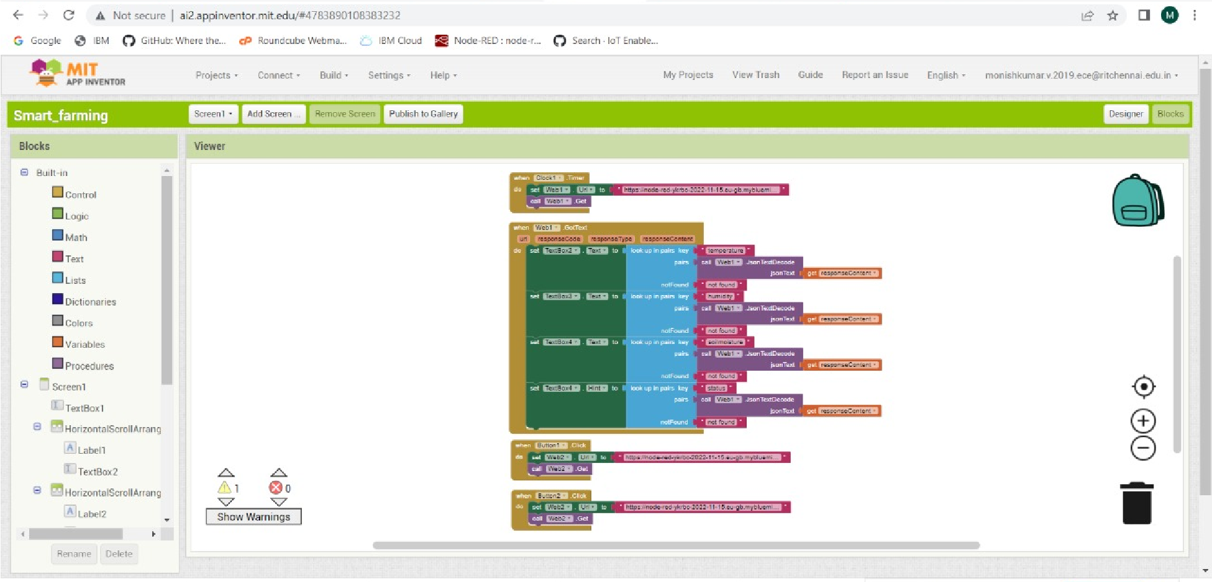**Step 3:** Backend Block

# **Step 4**: Build the App & Install

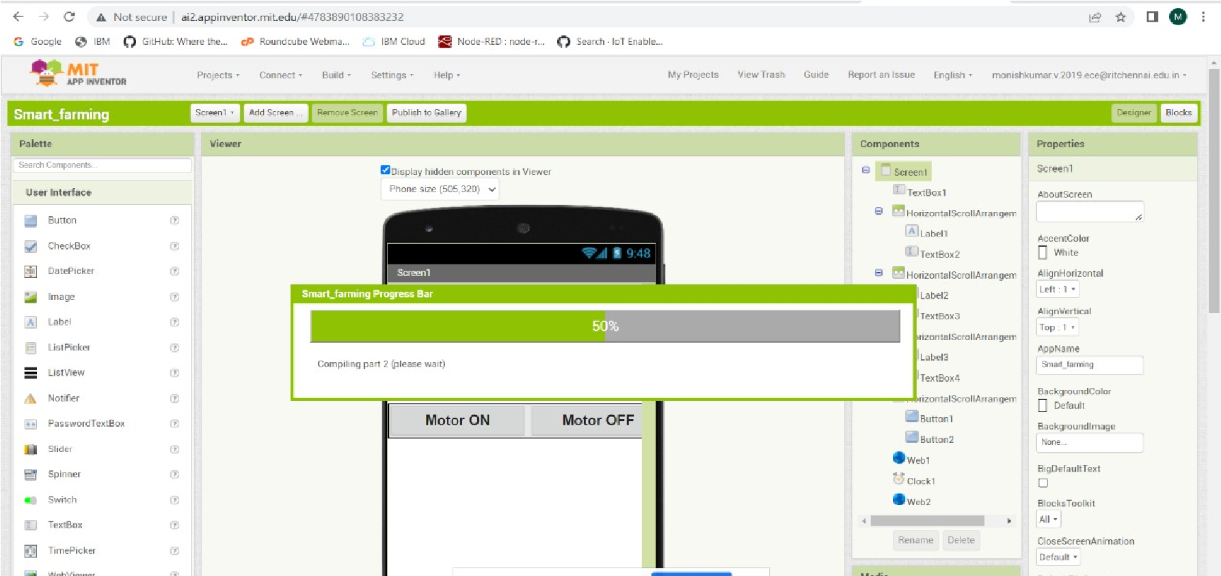

# **Step 5:** Status or Output

